S
INNOVATION LAB HIGH SCHOOL
2023-24 Course Request Instructions
10th to 12th Grades

Please use the course catalog and choose classes carefully
~ You are not registering for classes. You are requesting the classes you want to take ~

ILHS Course Request Timeline

- Monday, March 13th – Course request forms handed out to current 11th grade students during Crew

- Tuesday, March 14th – Course request forms handed out to current 10th grade students during Crew

- Thursday, March 16th – Course request forms handed out to current 9th grade students during Crew

- Monday, March 20th – StudentVUE opens for current 11th grade students to make requests. The requests made on the forms need to be entered the same on StudentVUE.

- Tuesday, March 21st – StudentVUE opens for current 10th grade students to make requests. The requests made on the forms need to be entered the same on StudentVUE.

- Wednesday, March 22nd -- StudentVUE opens for current 9th grade students to make requests. The requests made on the forms need to be entered the same on StudentVUE.

- Thursday, March 23rd – Request forms for current 11th graders due back in Crew.

- Friday, March 24th – Request forms for current 10th graders due back in Crew.

- Monday, March 27th – Request forms for current 9th graders due back in Crew.

- Monday March 27th – Friday April 7th – 1:1 meetings with Mr. Cohn during English class to go over students’ requests and make sure they’re on track with graduation requirements. If they are absent during these meetings, Mr. Cohn will meet with them the week after Spring Break (April 17-21).

Students should check school email frequently and parents should make sure that their contact information is up to date in ParentVUE.

Questions?
Email Jon Cohn at jcohn@nsd.org or Jane Hartway at jhartway@nsd.org with questions.

Course Request Worksheet Instructions
For a complete list of graduation requirements, turn to pages 6 and 7 of the Course Catalog.

- English and Crew are required (4 boxes – already filled in for you).

- Three years of math is required. We recommend that you take a math class each year. (2 boxes)

- Three years of science is required. A 4th year is recommended. (2 boxes)

- Two consecutive years of the same World Language is an ILHS expectation. At least two years is also required for admission to most colleges and universities (2 boxes).

- Choose 1-5 electives (at least 2 boxes)

- Choose at least 4 semesters worth of alternate electives
**if you don’t make enough alternate selections, and your first request is not available, you will be placed into a new elective at the discretion of your Counselor

- Review selections with a parent or guardian and sign course request form.

- Return to Crew advisor by the date specified for your grade level on the previous page.
ILHS Online Course Requests Instructions
StudentVUE
Step 1: Log-on to StudentVUE and click on “Course Request” located on left side of screen.
User Name – Student ID # Password – Use your student created password
Step 2: Click on this button to navigate to the screen where you can begin adding courses:

Step 3: Begin entering the Course ID for the math class you would like to take. Use your Course Registration Worksheet to find the correct Course ID for each class: Do not type anything in “Course Title” or choose from the drop-down box next to “elective”. Leave as is. For Example, Course ID ENG200 will give you both the A and B option for English 10. Make sure you choose both since you are requesting a year-long class.
**Repeat process with World Languages and electives

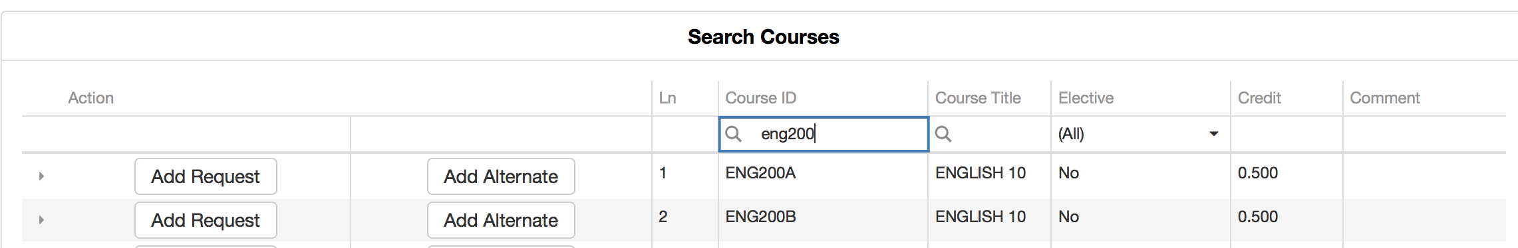

*Each time you select add a course request, it will be visible under your selected course requests.

Step 4: Once all 14 requests are in, then add your Alternates by choosing the alternate button.
These are your back-up classes. Enter at least 4 of them.

Step 5: When you have finished entering your requests and alternates, double check your work by clicking on the on the “Return to Course Summary” button.

Step 6: When you are done entering your classes and alternates, double check your work, then you can close the window and your work will be saved

